**What Is Python Matplotlib?**

**matplotlib.pyplot** is a plotting library used for 2D graphics in python programming language. It can be used in python scripts, shell, web application servers and other graphical user interface toolkits.

**What is Matplotlib used for?**

Matploitlib is a Python Library used for plotting, this python library provides and objected-oriented APIs for integrating plots into applications.

**Matplotlib’s Varieties:**

* **Basemap**: It is a map plotting toolkit with various map projections, coastlines and political boundaries.
* **Cartopy**: It is a mapping library featuring object-oriented map projection definitions, and arbitrary point, line, polygon and image transformation capabilities.
* **Excel tools**: Matplotlib provides utilities for exchanging data with Microsoft Excel.
* **Mplot3d**: It is used for 3-D plots.
* **Natgrid**: It is an interface to the natgrid library for irregular gridding of the spaced data.

## ****Python Matplotlib : Types of Plots****

There are various plots which can be created using python matplotlib. Some of them are listed below:

1. Bar Graph
2. Histogram
3. Scatter Plot
4. Area plot
5. Pie Plot

Basic codes in python matplotlib in order to generate a simple graph.

from matplotlib import pyplot as plt

**#Plotting to our canvas**

plt.plot([1,2,3],[4,5,1])

**#Showing what we plotted**

plt.show()

**Output:**

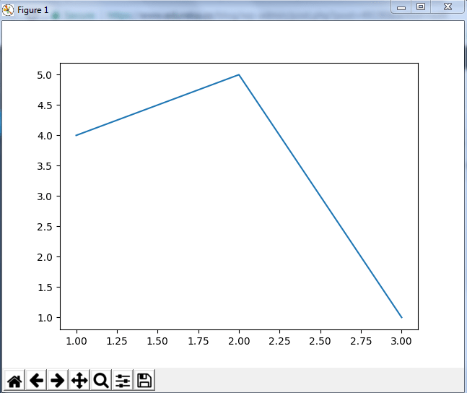

So, with three lines of code, can generate a basic graph using python matplotlib.